Lakeview Community Centre General Meeting Minutes Date: April 9th, 2019

Call to order: 2:30 pm

8 members attended the meeting plus 6 executive

Thank you to Blair Scanton for organizing a presentation by Cathy Semchuck. She is the Emergency Program Facilitator for the CSRD.

Her presentation was very informative, describing the processes that are now in place if disaster hits in our region. Many areas have taken the next steps of having volunteer neighborhood coordinators in place to be the contact between their area and the CSRD Emergency Program during a time of disaster. St Ives has been using this process for many years. There are no coordinators with the CSRD in place in the Anglemont or Magna bay areas at this time. Questions to ask yourself: Do you have enough water, Meds, Food, or Gas to survive for 72 hrs. at a minimum. Do you have a ToGo Kit to grab at a moment’s notice with critical information about Doctors name and number, Insurance info, Banking info, Birth certificates etc.? Do you have an emergency contact list in place, do you have a place to meet if you should become separated from your family? If you say no to most of these questions, then you are not prepared and are putting yourself and family at risk.

The 8 members that attended the meeting saw the presentation and most of them agreed that we need to do something to prepare our neighborhood. I would like to suggest we should have Cathy Semchuck return and give the presentation again expecting a better turn out. I look forward to feed back as to interest in following up with another presentation with better attendance at the presentation.

Directors reports:

President:

1. Want to thank Dolores Beck for years of volunteering. She has stepped down as events Director. We are looking for someone to fill the role.
   1. Dolores will continue to look after the sunshine cards.
2. We continue to work to get members to sign up for the volunteer lists. Remember the more that sign up the less we have to call on you.
3. Hall and yard clean up on Friday. Lunch provided.
4. We still need a **Secretary.**
5. Thank you to Tony Hudson for taking on the 1st Vice President position.

Maintenance report:

1. Fire extinguishers have been inspected for 2019
2. All emergency lighting has been tested and passed.
3. All smoke detectors and Alarm bell system has been tested and passed
4. New Canadian Flag has been installed
5. The Mailbox area is the Muster point for evacuation and we need to make a Muster sign.

Upcoming Events report:

* April 12th Centre Cleanup 9am -12 pm with a lunch provided by Centre to follow
* April 13th Breakfast sponsored by Right Choice camp and Catering
* April 20th Lions Club Meat Draw
* April 25th to ay 4th P&W tickets from Lorri S
* May 11th Breakfast Sponsored by Frank and Zita Barcza
* May 18th Lions Club Meat Draw
* May 24th ***FareWeller  to Judy and Reg old Time Dance***

Friday May 24th Doors open @ 5:00pm

Tickets $15.00 plus bring a finger food (appies)

Cash Bar,  50/50 Draw, Door prizes and Spot prizes for dances.

Dance to the old time music of Black Velvet Band.

Come say goodbye to Reg and Judy Weller long time residence and volunteers

of the area or just come to dust off your dancing shoes and visit friends.

Tickets available at Ross Creek store or call Darla Dingeldein @ 250-299-2158

* June 1st , 15th and 29th Lions Club Meat Draws.
* June 8th –Monthly Breakfast. No Sponsors as of yet for breakfast. If you would like to sponcer please call Jim D or email.
* June 8th Junk in the Trunk Sale in conjunction with monthly Breakfast, **Contact Darla D or Suzanne D for further info.**
* June 16th Lions Club Father’s Day Poker Run 2 Stations. We have all the volunteers we need.
* July 1st - July 1 Celebrations – time to be determined - Band has been Booked

Grant report: We have been working on a list items that we feel could be paid for by the grant process.

Treasures Report

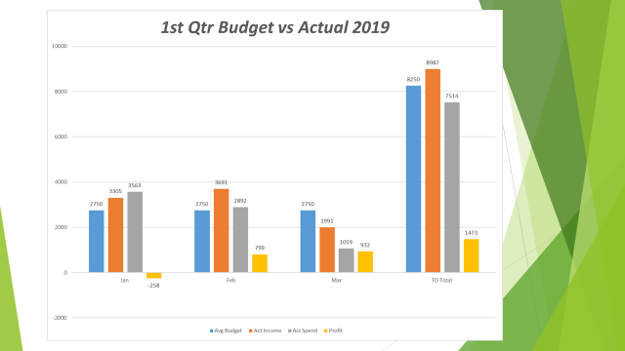



Membership report:

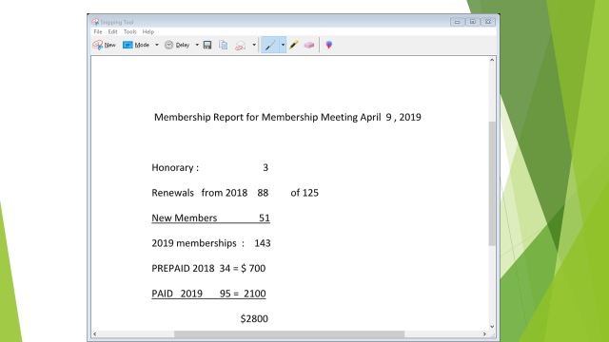

Next meeting 2nd Tuesday of May at 2:30 pm